TITLE OF THE PAPER
(TIMES NEW ROMAN, 14 FONT SIZE, CENTERED)**
AB Author^{1*}, CD Author², and EFG Author³
¹ Affiliation
² Affiliation
³ Affiliation
*Corresponding author’s email address
Abstract
The abstract should be written in Times New Roman, 11-point font, single-spaced. The word limit is 250 words. The top, bottom, and right margins should be 2.5 cm, and the left margin should be 3 cm. Use the same font sizes and styles as shown in the template above for the title, author names, and affiliations. The presenting author’s name should be underlined. The corresponding author must be marked with an asterisk (*), and their email address must be provided as shown above.
All abstracts must be prepared in English (UK) using MS Word 2007 or 2010 and saved as a Word 97-2003 document (.doc).
The abstract should briefly highlight the research problem, objectives, methodology/experimental design, results, discussion, and conclusion. Section headings are not allowed and citations, references, figures, and tables should not be included in the abstract.
Keywords: A minimum of three or Maximum five keywords should be provided, separated by commas.

** The title should be brief, specific, and reflect the study conducted. If scientific names of organisms/ plants are included, they must be written in italics according to the standard format. If common or vernacular names are used, they should follow the scientific name and be placed in parentheses. Do not use abbreviations or acronyms in the title unless absolutely necessary. Non-English and technical terms should be italicized.

Extended Abstract
The extended abstract provides a more detailed version of the abstract, outlining the research work and its outcomes. It should begin on the second page, following the abstract. Organize the extended abstract into sections: Introduction, Methodology/Experimental Design, Results and Discussion, and Conclusion.
Introduction
The introduction should offer a brief background to the study, outline the research problem, and state the objectives.

Methodology
The methodology should be concise but sufficient to understand the research design. Supporting figures, tables, and images may be included where necessary.

Results and Discussion
Results and discussion should be combined, focusing on the main conclusions of the study.

Conclusion

References
References should be listed alphabetically on a separate page in Harvard format. References should be limited to five main references.

The extended abstract is limited to four pages, excluding the abstract and references, using Times New Roman, 11-point font, single-spaced. Margins should remain as specified above (2.5 cm top, bottom, and right; 3 cm left).
Tables, images, and figures should be centred. Figures and images must be numbered (e.g., Figure 1), with legends placed below. Tables should also be numbered (e.g., Table 1), with headers above the table. A maximum of two tables or figures is permitted.

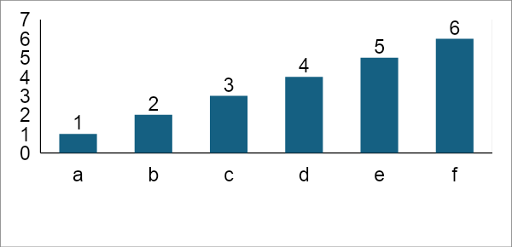
Figure 1. Figure caption

Table 1. Table caption
Item | Description

